Module 1b

Moving the Robot

# Introduction to Motor Blocks

## Motors

The motors are used to make your robot perform actions. There are 2 sizes of motors, the medium and the large.

### Medium

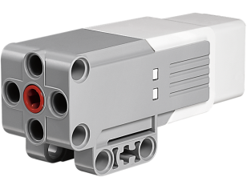

### Large

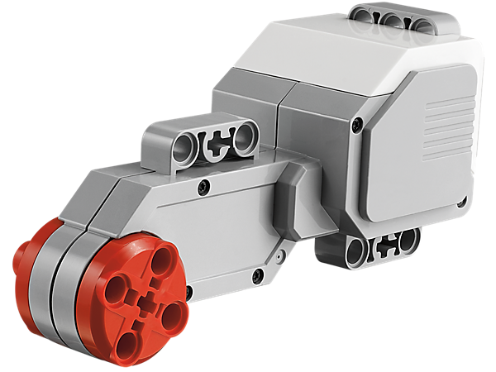

## Single Motor Blocks

The blocks used to control these motors are explained below.

### Medium

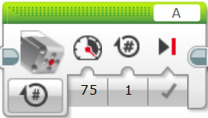

Menu

Power

Distance

Speed

Motor Port

### Large

This block is exactly the same except for the image of a large motor on it.

## Double Motor Blocks

### Move Steering

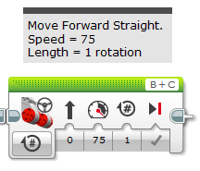

Left Motor Port

Right Motor Port

Direction of Movement

Power

Brake when finished

Number of Rotations

Menu

### Move Tank

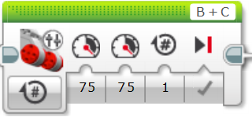

Left Motor Port

Right Motor Port

Left Motor Power

Right Motor Power

Brake when finished

Number of Rotations

Menu

# Activity 1 – Moving Straight

## Move Steering

Move forward 5 rotations in a straight line using the block below.

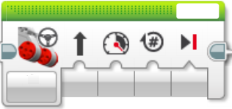

## Move Tank

Move forward 5 rotations in a straight line using the block below.

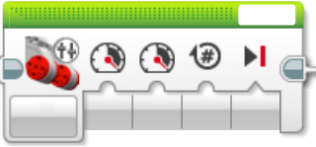

# Activity 2 – Turning

1. Move forward 2 rotations, turn left in one spot as shown below. Then move forward 1 rotation. Use the move tank block in to turn.

*Hint – What happens if the power on the left and right motors are different?*



Repeat part a using the move steering block.

*Hint – What happens if the direction is very high?*

1. Make the turn shown below using the move steering block.



1. Repeat part c using the move tank block.

